**ASAD Project Report**

**for**

***Airport Pickup and Temporary Accommodation for International Students***

**Prepared by**

**ANAGHA GHATE [U50030022]  
ARUNVAIBHAV KONAKANCHI [U54922072]  
GAURAV KULKARNI [U48445154]   
SRIRAM VOONNA [U14167622]**

**Muma College of Business  
University of South Florida**

**15 November 2016**

1. **Abstract**

The 21st century is an era of transformation from manual paper-based systems to an automation. While we, being graduate students in Information System stream, always find the automated connectivity within the USF so good, there is still an area where the automation is a prime necessity.

USF, Tampa has a student association which provides airport pick-up and temporary accommodation service to incoming USF students. Though they make their best efforts to provide seamless service, there are various drawbacks which cause a considerable inconvenience to the stakeholder at each level. After a comprehensive study of current manual system, we concluded that the present system lacks several important factors like transparency, reliability and centralization.

We have designed and developed an automated system for airport pickup and temporary accommodation services to incoming USF, Tampa students. We have ensured that our system has tried to eliminate the above specified drawbacks and has made the process simple, reliable, centralized and transparent.

We are very thankful to Professor Shivendu for his valuable guidance.

1. **Table of Contents**

|  |  |  |  |
| --- | --- | --- | --- |
| **Section** | **Sub-Section** | **Description** | **Page** |
| 1 |  | Abstract | 1 |
| 2 |  | Table of Contents | 2 |
| 3 |  | Background | 4 |
| 4 |  | Motivation | 4 |
| 5 |  | Approach to the Problem | 5 |
| 6 |  | Software Requirements Specifications | 6 |
|  | 6.1 | Overall Description | 6 |
|  | 6.2 | External Interface Requirements | 9 |
|  | 6.3 | Functional Requirements | 22 |
|  | 6.4 | Input Requirements | 29 |
|  | 6.5 | Process Requirements | 30 |
|  | 6.6 | Output Requirements | 32 |
|  | 6.7 | Other Non-functional Requirements | 34 |
| 7 |  | UML Diagrams | 37 |
|  | 7.1 | High Level Block Diagram | 37 |
|  | 7.2 | Data Flow Diagram | 37 |
|  | 7.3 | Use Case Diagram | 38 |
|  | 7.4 | Class Diagram | 38 |
|  | 7.5 | Activity Diagram | 39 |
|  | 7.6 | Sequence Diagram | 39 |
| 8 |  | System Documentation | 39 |
|  | 8.1 | Advantages | 39 |
|  | 8.2 | Limitations | 40 |
|  | 8.3 | Session 9 Quiz 2: Product Metric | 41 |
| 9 |  | Future Recommendations and Scope | 46 |
| 10 |  | Glossary and Index | 47 |

1. **Background**

Every year during Spring and Fall intake, many international students decide to take a step into the future by selecting the University of South Florida, Tampa for their Undergraduate or Graduate studies. The first step every international student look for is airport pickup and temporary accommodation.

Currently, many students rely on social networking sites, to arrange temporary accommodation and airport pickup. But this system is not completely sophisticated as there might be redundancy in requests, lack of clarity in point and time of arrival, sudden unavailability of pick up and accommodation, security issues, hyped costs for travel and transparency.

We would like to mention some of the difficulties faced by our friends who were looking for temporary accommodation and/or airport pick-up. Some of the students were not offered airport pick-up. Some of them could not get temporary accommodation even though they were confirmed about that few days prior to the arrival in Tampa. Few students could not find confirmed person to pick them up at the airport. These issues generally make students’ arrival in the entirely new land very awful and stressful.

1. **Motivation**

Since these issues are very critical if security, inconvenience and safety is concerned, we decided to design and build an information system that will address the problems faced by each of the stakeholders involved in the process. This application will be integrated with USF admissions and international services existing applications to provide reliable services to the incoming students.

We have done research and intend to provide an optimized information system to the USF team (like SIA) so that they could help many incoming USF students. We have achieved this by creating a common interface, using web technology and database concepts, between the service provides and incoming students. The students who have their Visa approved for USF, Tampa will register into the application. They will submit their documents required by the application and admins will verify the documents. As per the request of each student (either airport pick-up, temporary accommodation or both), the admin will check the availability of the pick-up person and the availability of accommodation. These details would be conveyed to each student and a confirmation e-mail would be sent automatically from the application to the registered e-mail id of the student.

This system will address the aforesaid potential issues like redundant requests, security and transparency efficiently. Furthermore, our system design emphasizes on how to eliminate sudden delivery issues like, sudden unavailability of pickup, delayed flight arrival to the maximum extent.

1. **Approach to the Problem**

Gathering the requirements and preparing a comprehensive Software Requirements Specification document is the initial and a key process of developing an entirely new information system. As the motivation, which led us to think about developing this information system, is based upon real-time issues faced by students of USF, Tampa, we decided to meet them in person and ask about their experiences. Their experiences gave us more insights into the requirements gathering and analysis phase of this application development. We also contacted the service providers and tried to understand how their existing manual system is functioning and what kind of obstacles they come across and what are the very common reasons, while offering services to students.

The students, whom we surveyed, were typically opted the airport pick-up and/or temporary accommodation services in Spring,2016 and Fall,2016. The unexpected difficulties they faced, as mentioned above, range from unavailability of pick-up person, logistics to the cancellation of temporary accommodation that was confirmed to them beforehand.

The feedback that we received from students and service providers was very valuable and helpful to prepare our SRS. The important factor of which students were unsatisfied, was the missing single point of access. This simply means that, even the students who did not find any issues in services were recommending the online portal for the end-to-end process. Students seemed to be unhappy with the communication channels like Whatsapp, through which the messages were conveyed. Also, the requesting the service through Google forms and contacting the officials on Facebook should not be the preferred medium of communication, as suggested by number of students. The service providers’ problems were mainly to manage the availability of pick up people and temporary accommodation service providers. Due to the absence of a web application, they need to skim through the Facebook and Whatsapp communications with these officials and accordingly convey the messages to requesters. This process, per them was not quite reliable.

The expectation of requesters and service providers from the developers was that there should be a web application which has sufficient user accessibility, reliability, very high uptime, security and well defined modules (separate forms) for all the available services. This application must strive to minimize the manual workload over the service providers.

1. **Software Requirements Specifications**

**6.1 Overall Description**

The application deals with the idea of helping incoming international students into University of South Florida. The main issue faced by the students are: airport pick-up, temporary accommodation, security with their luggage and welcoming face upon entry into the new world. To provide this healthy start and all the other services we developed a system. Our system starts with air-port pick up for the incoming student and ends with providing a temporary accommodation of 4 days. There is a current system present in USF which provides many of these services, it could be made better and more streamlined. Our system handles all the issues faced by the current system and provides a simple solution to these. Our system has three main actors: administrator, incoming student, and service provider. We will start the story from the incoming student’s perspective.

Once a student receives an acceptance mail from the university a link to register for the “Air-port pick up and temporary accommodation services” will be provided. Upon selecting the link the student will be directed towards an online registration form. In this form, all the student details like USF Id, name, incoming semester, whether the student requires any of the services (airport pick-up, temporary accommodation up to 4 days or both) are recorded. This recorded information goes through first level of validation during the fill up process and then the second level validation is done at the university end, the details are cross-verified with university database. The student then receives an account activation link via email id. This link will direct the student to a login page where he/she can log in using the USF net id. Once logged in the home page provides plethora of options the student can do. If the student selects an airport pick up, the student will be required to provide arrival date in Tampa, flight number, number of baggage, drop off address, contact information. The admin and service provider will use this information. If the student opts for temporary accommodation, he/she must provide the start and end date of the temporary accommodation. If both the details options are selected the student must provide all the details for both the services. After service registration, the status for the selected service for a student remains “Pending” status. Once a service provider is available the status will be changed to “Confirmed” and the student will be provided with the corresponding service provider information and vice versa so that they can contact with each other.

Coming to the service provider perspective there are 2 ways a service provider can enter the system. The first one is the interested service provider will contact administrator offline and provide his/her email address and then the admin will send a registration link to that person. The second one is an existing service provider can refer a new service provider and a registration link will be sent to the new person. The registration link redirects the new service provider to “Service provider registration form”. His/her details like USF ID, name, type of service provided, vehicle registration number, international license number, passport number etc. If the service provided is temporary accommodation, then the service provider is required to provide the lease agreement of his/her apartment. To validate the person the admin requests a few more documents; the service provider should mail a scan copy of these documents. Once validated the service provider will receive an account activation link. This link will allow the service provider to log in to the system with his/her USF net id. Once logged in the service provider will be able to perform multiple operations like: view the list of students registered for the service provided by him/her. He can update his/her service details, availability details in this page. If the service provider is not available, he/she can re-route the service to another by requesting cancellation. Along with these options this service provider will be able to refer another service provider to increase the range of the system.

The final actor in the system is the administrator. The administrator directly logs into the system. He/she acts a medium between different levels: student and university validation, student, and service provider. Administrator provides account confirmation links student and service providers, only then they can log into the system. The administrator can map a student with a service provider. The administrator can also add new service providers to the system. Thus, the administrator plays an important role in this.

The students (enrolled for any other service) are requested to carry an addition 100$ with them. This money is considered as a deposit amount. After the service is completed the student will be give back the remaining amount. The accommodation for four days is 25$ and the air-port pick up all the students share service charge the vehicle. All the money transactions are done in cash, there is no online payment system included in the system. As the students and service providers are validated beforehand the security constraint is fulfilled. This system will help the student to adjust into the USF system more conveniently.

We have chosen **Waterfall Model** as our process model.

* Simple Model
* Requirements are frozen
* Each phase has specific deliverables
* No overlapping of phases
* Suitable for small projects
* Low Cost

Assumptions-

We have made the following assumptions with respect to our project and they are as follows. This is not an exhaustive list but a list of the most critical assumptions.

1. Integration with USF's International Services system.

2. Admin will have access to all the modules of application along with back-end.

3. Automatic allotment of services based on FCFS and as per availability.

4. Hardware support - 500 people at a time.

5. Manual Payment due to security constraints.

6. Manual verification of systems by Admin is for service provider

**6.2 External Interface Requirements**

1. **Student Registration form**: Every student is provided with a registration form. Here all the student details are noted down here and they are validated with university database.

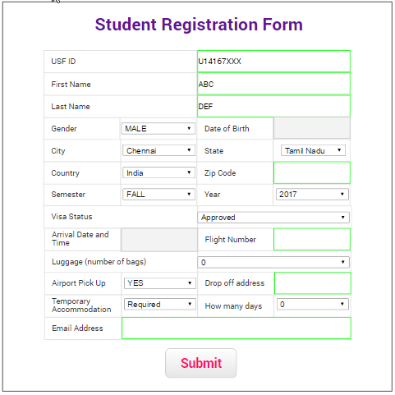

1. **Student Login Form**: Once the student details are validated an account activation link is sent to the university email if of the student. Student can log in using his/her university net id.

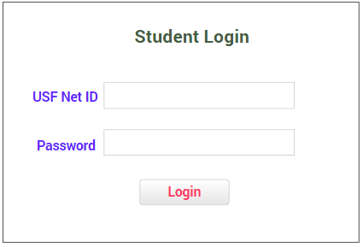

1. **Student Home Page**: Every student is visited with a home page where he/she could navigate through many options.

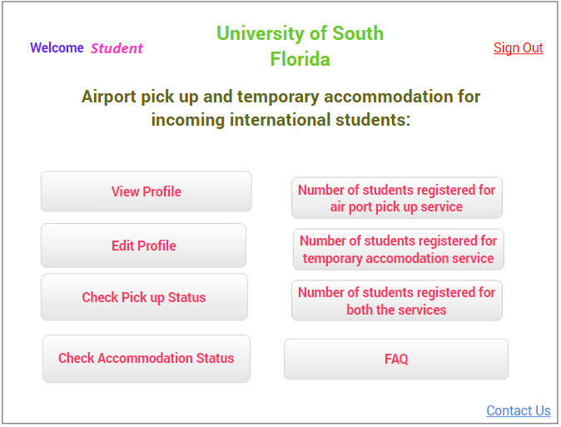

1. **View Student Profile**: The student profile can be accessed using this button.

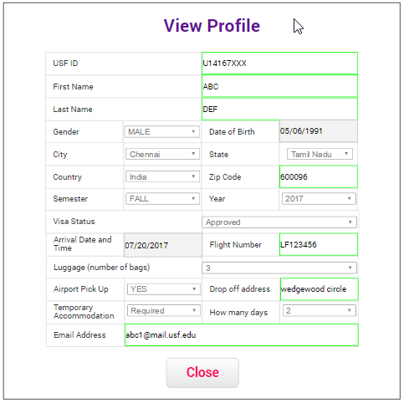

1. **Update/Edit the profile**: Student can update profile details, like visa status, Flight Number, drop off address, number of days of temporary accommodation etc. Only a few details can be updated. Details like USF ID, name, gender details can’t be altered.

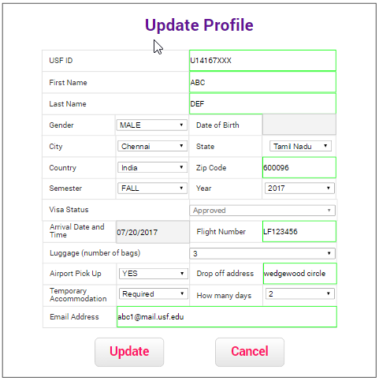

1. **Check Pick Up status**: Pick up status of the student is updated here. Student can view the contact details of the pick-up person by clicking the button in this screen.

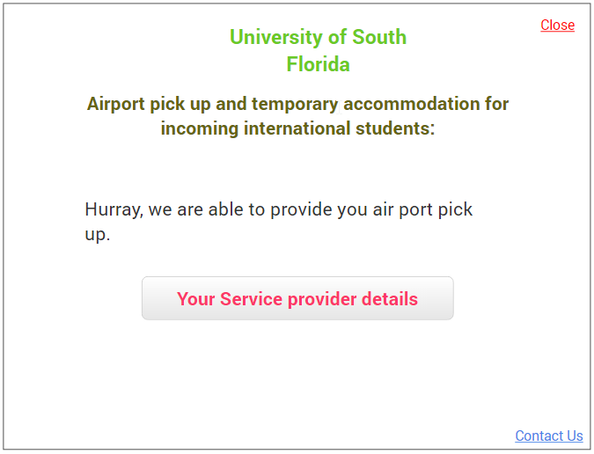

1. **Check Accommodation Status**: Temporary accommodation of the student is updated here. Student can view the contact details of the pick-up person by clicking the button in this screen

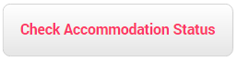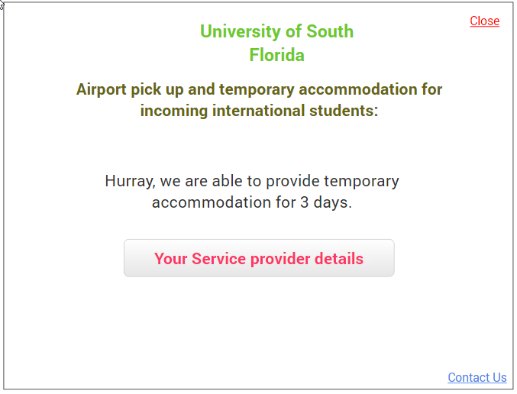

1. **Number of students registered for airport pick up service**



1. **Number of students registered for temporary accommodation service**



1. **Number of students registered for both the services**



1. **Frequently Asked Questions**

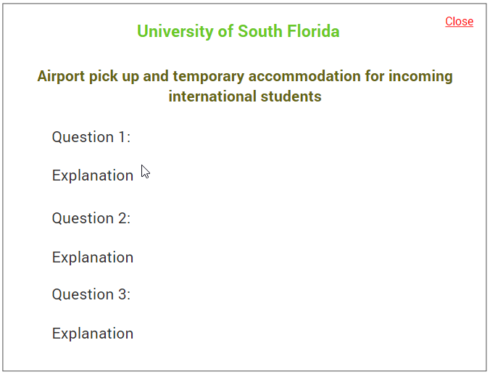

1. **Admin Contacts**: Students can contact admin and their details can be found here.

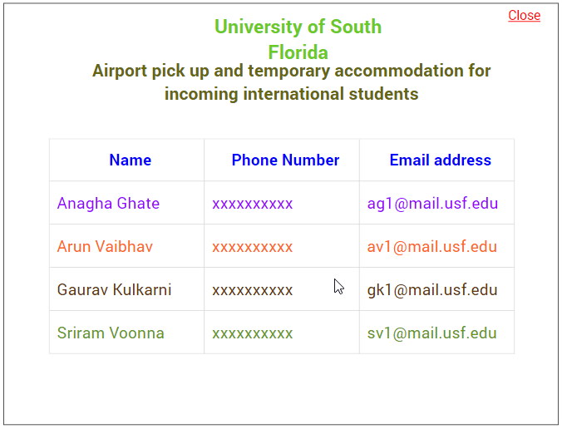

1. **Sign Out**: Once verified the student can sign out of the account.

**Administrator**:

1. **Admin Login**: This login is available for the administrator to perform his/her activates.

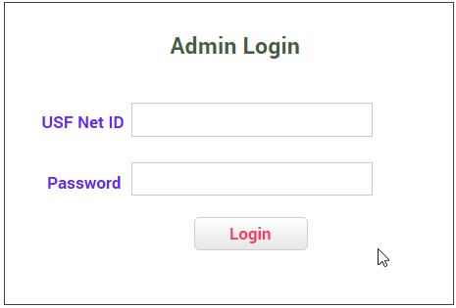

1. **Admin home page**: This admin page consists of many functionalities that an admin can perform.

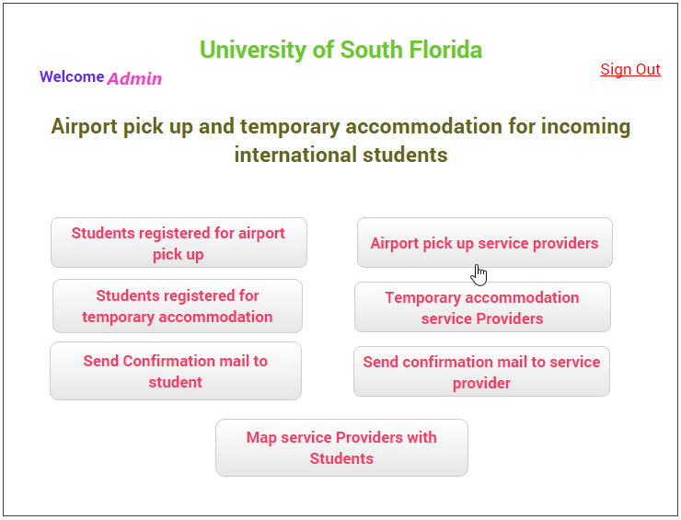

1. **Students registered for airport pick up**: The list of students registered for the airport pick-up service can be listed out in this screen

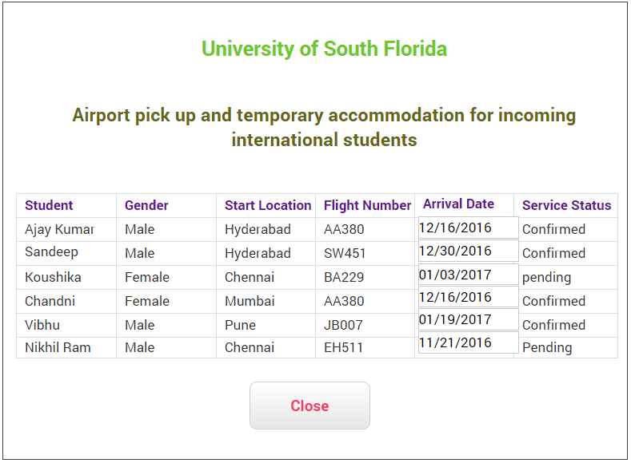

1. **Students registered for temporary accommodation**: The list of students registered for the temporary accommodation service can be listed out in this screen.

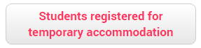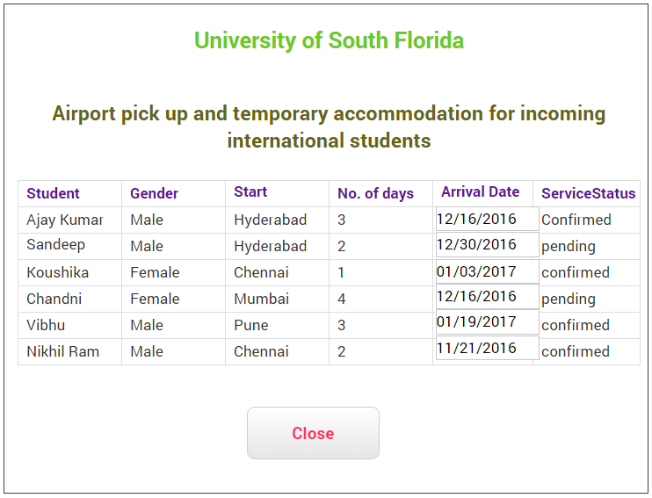

1. **Airport Pick-Up Service Providers**: This screen lists all the service providers who provide the airport pick-up for incoming students.

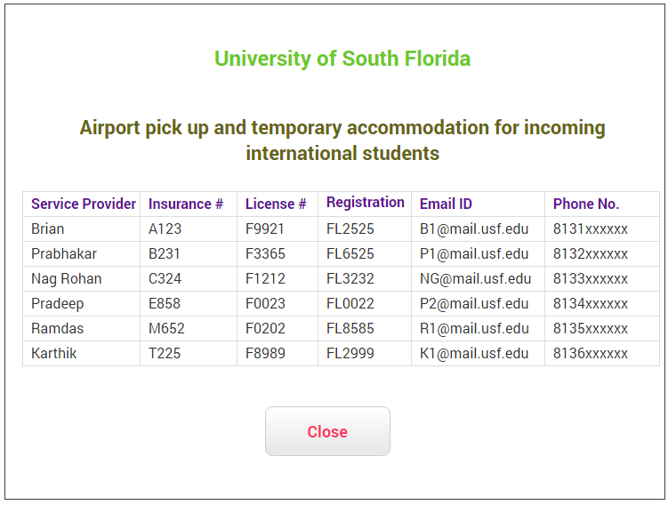

1. **Temporary accommodation service providers**: This screen lists all the service providers who provide the airport pick-up for incoming students.

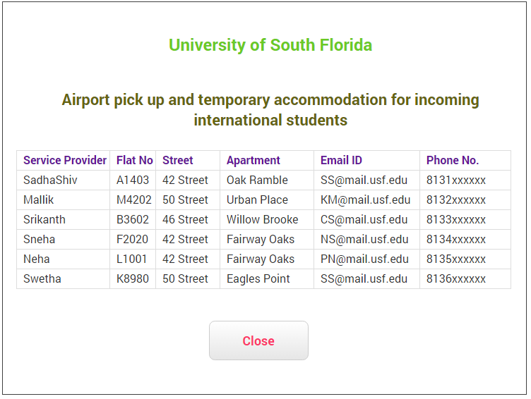

1. **Send confirmation email to student**: After the student submits the registration form the details are validated by the USF database and a confirmation mail is sent to admin. Then the admin uses “Send confirmation mail to student” to send account activation link to the student, only then the student can log in into his/her account.

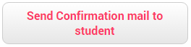

1. **Send confirmation email to service provider**: After the service provider is validated (by the admin) the admin uses “Send confirmation mail to service provider” to send account activation link to the service provider, only then the service provider can log in into his/her account.



1. **Map service providers with students**: Our application maps the students with service providers based on their availability. The admin is provided with access rights to make changes in the mapping.

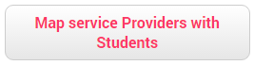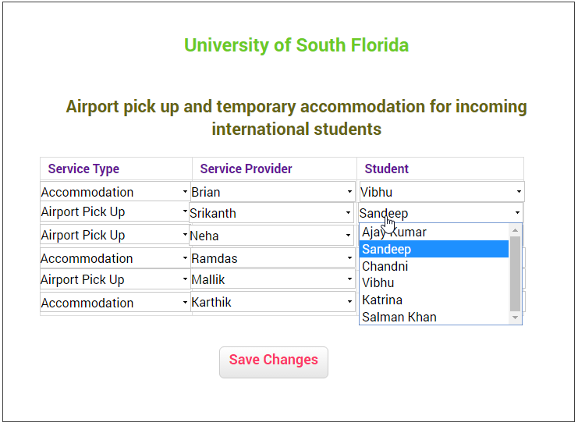

Service Provider:

1. **Service Provider Registration Form**: Just like the student registration form, a service provider registration form is also available. Using this form the details of the service provider and the type of service provided by him/her are entered

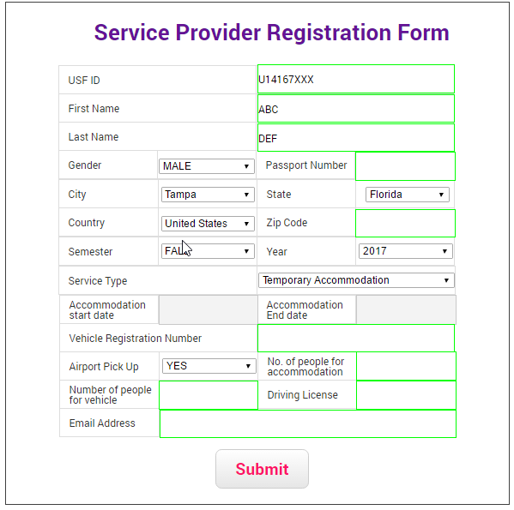

1. **Service Provider Login**: Once the details of the service provider are validated an account activation link will be sent to the service provider (university mail id). That link would allow service provider to log in.

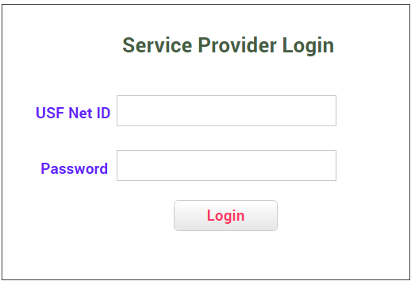

1. **Service provider home page**: The service provider can log in with their USF net id. Once logged in they are welcomed with a home page with plethora of functions built into it. The service provider can perform different tasks, update his/her status about the service in this screen.

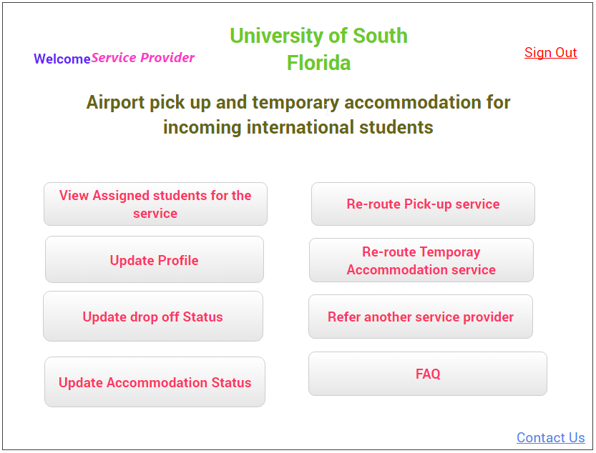

The options are:

1. **View Assigned students for the service**: List of all the students assigned to the service provider.
2. **Update Profile**: The service provider can update the service details.
3. **Update drop off status**: The service provider can update the drop off status after the pick-up
4. **Update accommodation status**: The service provider can update the temporary accommodation status.
5. **Re-route Pick-up service**: This is to request the admin that another service provider will be taking up the task instead of him/her.
6. **Re-route Accommodation service**: This is to request the admin that another service provider will be taking up the task instead of him/her.
7. **Refer another service provider**: This allows a service provider to introduce another service provider into the system.

**6.3 Functional Requirements**

Our Information system should facilitate many requirements. When Agility is considered, system should be designed in such a way to facilitate and integrate the change in requirements. However, since we have decided that we will be using waterfall model, we assume that we do not consider change and update in the functionality and fix our requirements. Also, for convenience, we listed requirements which are prioritized as “High”.

**6.3.1 Student Registration support system**

6.3.1.1 Description and Priority

This module is intended to accept student registration details and create student login information. This module enables the system to support the primary functionality which is student’s registration and student’s login. This is a “High” priority requirement since this functionality is a basic one and mandatory. This functionality also, let’s students to receive credentials and login once the admin verifies and sends the login information. It also has further inherent functionality to support the user (here student) to view, update profile, check pick up status, accommodation status, FAQ etc.

6.3.1.2 Stimulus/Response Sequences

*Stimulus: Student initiates registration process if he/she is a new user.*

*Response: System responds by opening a new blank registration form, to accepts user’s inputs*

*Stimulus: student enters his details and submits the registration form.*

*Response: System displays a message “Thanks for registering with us, we will email you the login credentials shortly”.*

*Stimulus: Student receives an e-mail after successful process of his validation and navigates to login page*

*Response: System asks login credentials.*

*Stimulus: User enters login information*

*Response: System logs in the user into the system if the user enters correct information, else, throw ‘invalid credentials, please try again’’ error.*

*Stimulus: Student clicks on “View Profile”*

*Response: System shows the student’s information provided by the student at the time of registration.*

*Stimulus: Student clicks on “Edit Profile” if he wants to edit his profile,*

*Response: System opens up an Edit Profile page and lets the user to enter modified information.*

*Stimulus: Student clicks “Check pick up Status” to check his pick up status.*

*Response: System displays the pickup status whether or not he was allocated with a pickup with details.*

*Stimulus: Student clicks “Accommodation Status” to check his accommodation status.*

*Response: System displays the accommodation status whether or not he is allocated with the accommodation, if yes the number of days of accommodation allocated is displayed.*

*Stimulus: Student clicks on “Number of students registered for air pick up service” , “Number of students registered for temporary accommodation service”, “Number of students registered for both the services”*

*Response: Students gets the number as response on the right side of the box.*

*Stimulus: Student clicks FAQ if he/she needs any help*

*Response: System navigates to question and answer page.*

6.3.1.3 Functional Requirements

EQ-1: When service provider clicks on “view assigned students for the service”, he/she should be able to view it in a tabular form with a download excel option that downloads on a single click.

REQ-2: When user enters invalid credentials, should say ‘Invalid Login’ and redirect to ‘Reset Login information’ page.

REQ-3: System should redirect to student login page when clicked on sign out.

REQ-4: System should not have any provision for any user to update his information in view profile tab.

REQ-5: System should allow student to view number of days of his accommodation when clicked check accommodation tab.

**6.3.2 Service Provider Support System**

6.3.2.1 Description and Priority

This module is intended for service providers. As per our requirement, there should be a separate system that facilitates all the people who intends to provide pick up service or accommodating incoming students, to first register and login into the system. This is a main component in the system hence it’s a “High” priority requirements. Also, this system is responsible to let service providers view their registration details, update drop status, reroute the service in case they are unable to pick up, etc.

6.3.2.2 Stimulus/Response Sequences

*Stimulus: Service provider initiates registration process if he/she is a new user.*

*Response: System responds by opening a new blank registration form, to accepts user’s inputs*

*Stimulus: Service Provider enters his details and submits the registration form.*

*Response: System displays a message “Thanks for registering with us, we will email you the login credentials shortly”.*

*Stimulus: Service Provider receives an e-mail after successful process of his validation and navigates to login page*

*Response: System asks login credentials.*

*Stimulus: User enters login information*

*Response: System logs in the user into the system if the user enters correct information, else, throw ‘invalid credentials, please try again’’ error.*

*Stimulus: Service Provider clicks on “update Profile” to update his/her profile.*

*Response: System shows the student’s information provided by the service provider at the time of registration.*

*Stimulus: Service provider selects “Update drop-off status” when he posts his available timings of pickup or drop.*

*Response: System sends the details to Admin for verification and displays a confirmation message.*

*Stimulus: Service provider clicks “Update Accommodation Status” to provide his/her available accommodation details.*

*Response: System accepts the details and sends the confirmation once accepted.*

*Stimulus: Service provider clicks “Re-route pickup service” for a request to admin to chek for another service provider.*

*Response: System displays he/she could do that at that point. If not, they are responsible to arrange the service at any cost and system displays the appropriate message.*

*Stimulus: Service provider clicks on “refer another service provider” option.*

*Response: System responds the appropriate window to accept the service provider’s name, e-mail, and contact number.*

6.3.2.3 Functional Requirements

REQ-1: When user enters incorrect data in registration form like alphabets in mobile number, system should through error stating that ‘Invalid Input’.

REQ-2: When system provider enters invalid Member ID should say ‘Invalid Login’ and redirect to ‘Reset Login information’ Page.

REQ-3: When user logs in the system should check automatically for the available pickup status and upload into the database, since when pulled it would showcase the information.

REQ-4: The user should be able submit the claims to the claim system and know the status as well in a single web page.

REQ-5: System should redirect to service provider login page when clicked on sign out.

REQ-6: System should allow service provider to connect to admin for redirecting the last minute undeliverable. In terms of pickup or accommodation services.

**6.3.3 Admin Support System**

6.3.3.1 Description and Priority

This module is intended for System Admins. Admin plays a key role in the entire system. When both student and service providers’ logs in and registers, both of their forms including their IDs and documents will be reached to the admin department, the admin verifies the authenticity of the information and mails the login information for the respective persons. Also, the admin is responsible for the ‘Match up’ service where the service provider and students are matched for the business to happen this is a main component in the system hence it’s a “High” priority requirements.

6.3.3.2 Stimulus/Response Sequences

*Stimulus: Admin logs into his portal.*

*Response: System opens admin’s home page.*

*Stimulus: Admin would like to see the registered students, and clicks on “students registered for airport pickup” and then students registered for temporary accommodation and clicks on “students registered for temporary accommodation.”*

*Response: System displays the list of students with their name, arrival date, service status etc. in a tabular form.*

*Stimulus: Admin verifies the registration forms for the student and wants to send conformation about the service and clicks “send confirmation Email”.*

*Response: System displays the message stating the confirmation was sent.*

*Stimulus: Admin would like to see the list of service providers for both temporary airport pick up and accommodation providers and clicks “Airport pickup service providers”, “Temporary accommodation service providers”*

*Response: A list of service providers for both the functionalities are to be displayed in a tabular form.*

*Stimulus: Admins wants to send a confirmation mail for the service provider after validating the details and clicks on “send confirmation mail to service provider”*

*Response: System displays the message stating the confirmation was sent.*

*Stimulus: Admins wants to map the students and service providers with one-one relation primarily for the business need to be done and clicks on “Map service providers with students” and submits*

*Response: System runs an algorithm to match both the tables and gives the finalized paired values, which are given to admin to validate and send confirmation mails.*

6.3.3.3 Functional Requirements

REQ-1: When Admin clicks to see the registered students or service providers, we need to get it in a tabular form with student name, gender, location, flight number, arrival date, service status etc.

REQ-2: An automatic communication interface is designed that sends emails if the admin wants to send a confirmation e-mail or e-mails that are sent with login Details etc.

REQ-3: A match up service should contain pre-defined algorithm to do the matchup services.

REQ-4: Functionality in the system should allow user to edit the mapping if he/s eh needs. It means the system should also have this option to select the mapping automatically or manual mode.

**6.3.4 Availability of Services**

6.3.4.1 Description and Priority

This module will be available to access for both the requesters (incoming students) and the service providers. The admin i.e. service provider will track the students’ requests and corresponding availability of the pick-up person and temporary accommodation provider. This module will fetch data from students’ information table, students’ service requests table, service providers’ (pick-up persons and temporary accommodation providers) table and their availability information table. Based upon the information available, admin will confirm the service providers over the form associated with the request from a student. This would send an automatic system e-mail to the requester as well as the two service providers.

6.3.4.2 Stimulus/ Response Sequences

Stimulus: Admin opens the availability of services page.

Response: The form will be displayed with the service requests and details of requester. Also, corresponding availability confirmed by both the service providers are shown against the requestors details.

Stimulus: Admin selects the pick-up person and temp. accommodation provider and associate them with the requester by confirming each of a requester, pick-up person and temporary accommodation provider.

Response: The automated system’s confirmation e-mail is sent to the above mentioned 3 parties.

6.3.4.3 Functional Requirements

REQ-1: Open_Availability_Form: Admin clicks on the ‘Availability of Services’ page.

REQ-2: Show_Availability_Details: Information system processes the request, executes the call on button and opens up the concerned page.

REQ-3: Select_Service_Providers: The form shows which service provider(s) are available for the requested time slots and/or the accommodation requirements of the requesters. The admin picks up the service provider(s) by ticking the checkboxes in each of the columns.

REQ-4: Send_Confirmation: Once the admin submits the selections of requester and corresponding service provider(s), the system will shoot automated system e-mails to each of requester, the pick-up person and stemporary accommodation provider.

**6.4 Input Requirements**

Here, we will define, what are the inputs needed for each system,

* For Student Registration: Student need to enter UID, First Name, Last name, gender, Date of Birth, City, State, Country, ZIP code, Semester, Year, Visa Status, Arrival Date and Time ,Flight Number, Luggage(No. of bags), questions and check boxes for , airport pickup needed, Temporary accommodation required, Drop address, days accommodation needed, Email Address and then a submit button.
* For Student Login : USF Net ID and password
* For Service Provider Registration:
  + Basic details like First Name, Last Name Gender, City, Country, passport number, Zip Code are to be entered.
  + Next, secondary information like semester, Year of admission, Service type that a service provider intends offer, here either airport pick up or accommodation, is to be selected.
  + In case of airport pickup, number of people he could pick up at that time, vehicle registrations needs to be entered.
  + In case of temporary accommodation, number of people he/she could accommodate, accommodation start date, and end dates needs to be entered.
* For Service provider Login: A login ID and password sent by admin needs to be entered.
* For Admin services:
  + A login and password needs to be entered to check in into the portal.
  + For match up, admin needs to select the student and should click on ‘send conformation’ mail services to confirm the service.

**6.5 Process Requirements**

We will define how the information is processed between Input entity and output entity,

6.5.1. For Student services system:

* + Once student enters the information, it joins the corresponding UID and password with the corresponding login entered and extracts the record from Student Database. It then extracts the exact student details and pops up the customized page.
  + If any students intends to register, when ‘registration’ is clicked, a fresh registration form with blank fields is created, whenever the user enters the information, a record should be created automatically in student database once he/she clicks submit.
  + When student clicks on ‘check pickup statuses and ‘check accommodation status’, a communication channel is opened, a link is created from database to the display and corresponding records are pulled out for view from the database.
  + Clicking to miscellaneous links like FAQ and contact us leads the user to navigate into the static HTML pages, which just displays the information stored in that page.
  + Clicking on Number of students registered will fetch the count from the database, also, in the same page itself, the total of both students registered for airport pickup and accommodation is calculated and the number is to be displayed.
  + Sign out, on clicking closes any active sessions and redirects to the main home page.

6.5.2 For Service Provider services system:

* + Once the service provider enters the information during registration a database session should be opened and automatically a new record should be updated in the database.
  + When the service provider logs in using the login ID and password sent by the admin, it redirects him to the customized service provider page, where he/she will be doing necessary tasks such as checking the pickup or drop, request for service etc.
  + When the service provider clicks on ‘view assigned students for the service’ a database session is again opened and fetches the records from the admin database which has same ID under service provider.
  + When service provider clicks on ‘reroute pick-up service’, or ‘reroute temporary accommodation service’ a web session opens and a flag is set for admin corresponding to the service provider’s ID that, the current service provider is not ready to offer the service. It allows the admin to do the match up again and set up a new service provider.
  + When service provider wants to refer another service provider a new HTML page is popped up asking name, contact details like email ID and phone number of the new person and this will be stored as a separate table in new service provider database.

6.5.3 For Admin services system:

* + Once the admin logs into the system using his credentials, a new web session is opened pertaining to corresponding admin details.
  + This session internally connects with all the servers and tables which contains students information as well as service provider information
  + When an admin logs in, he see several options and the web session and always connected to all the databases. For instance, a table of students who are enrolled for airport pick up is displayed in a neat tabular form. This is achieved by a command issued by the admin by clicking the option and this inbuilt serves as a SQL command to fetch all the necessary data. This is an important process requirement for admin services which is 24 x 7 connectivity.
  + All the view services are ensured full compatibility by continuous connectivity.
  + For the match up service, when the admin wants to finalize the business, he should match a student with the service provider. This might be from one-one to many – many. Hence, when he clicks ‘Map services with students’ an internal querying process runs and a database session opens which joins the student table and service provider table and displays the information side by side to enable the admin for match up.
  + When the matchup is done, the final step would be the admin should send out the conformation mail. For this functionality, the admin has access to mail IDs to the database hence the interface supports to open the functionality which has inbuilt mail recommendations. For instance, if the admin wants to confirm a student’s pick up and would like to send out a confirmation mail, first he clicks on save changes in the match up window, and then goes to his home page and click on send confirmation emails.
  + On single click, the system automatically retrieves all the mail IDs from the database which has Mail IDs in the student’s list and adds them into ‘TO’ section in the mail.

**6.6 Output Requirements**

6.6.1 For Student services system:

* + On submission of the new student registration form, a confirmation message should be shown the system.
  + After entering the login information given by the admin, a customized student home page is displayed. If the login information is invalid, an error message ‘Unable to login, invalid credentials’ error message should be displayed.
  + When the website is busy, ‘website busy, please try later’ should be displayed.
  + When ‘check pickup status’ is clicked, the webpage displays, the name of the driver along with the vehicle number and contact details of the service provider in a new web page, when clicked on OK, it comes back to student home page.
  + When ‘check accommodation status’ is clicked, the webpage displays whether the accommodation is provided or not along with number of days.
  + When other tabs like to check number of other students enrolled for the services is clicked, the corresponding numbers are displayed in the same page itself just a number pops up with the count of corresponding request on the right side of the box.

6.6.2 For Service Provider services system:

* + On submission of the new service provider registration form, a confirmation message should be shown the system.
  + After entering the login information given by admin, a customized service provider page is displayed. If the login information is invalid, an error message ‘Invalid login, please try again. If error persists, please contact admin services’ should be displayed.
  + When ‘view assigned student for the service’ is displayed, a list of students with their contact information who are enlisted for the services to be availed by the current service provider is displayed on the screen.
  + When a service provider clicks on ‘Update Drop-off status’ and ‘update accommodation status’ , a page with blank fields which enables the user to update the accommodation details available, so that admin would see this and assign the service.
  + When a service provider clicks on ‘Reroute pick-up service’, or ‘reroute temporary accommodation service’ a page opens to confirm the same, when clicked, a confirmation message appears to the service provider stating that, a re-route request is sent to the admin.
  + When a service provider clicks on ‘Refer another service provider’, a page opens to enter their name, phone number, email id and click on submit, once done, a confirmation message stating that ‘reference added’ will be displayed on the screen.

6.6.3 For Admin services system:

* + When admin enters his login, admin page will be opened.
  + When he clicks ‘Students registered for airport pickup’, ‘students registered for temporary accommodation’ a screen appears displaying records of the students who enrolled for different services.
  + When admin wants to look into ‘Temporary accommodation service providers’ , ‘airport pickup service providers’ a screen appears with the service provider along with the contact details in a tabular form.
  + When admin clicks on ‘send conformation mail to student’ or ‘send confirmation mail to service provider’ a bulk of mails by default will be sent to the entities and admin receives a confirmation message when all the messages are sent. If for any reason there is a delivery failure, admin comes to know by the error message on the screen. After seeing that, admin will be checking the detailed server log to know what exactly caused the error.
  + When admin clicks on ‘Map service providers with Students’ tab, a web page with all the students and service providers details will be opened side by side. Admin matches the service provider for the corresponding student and goes on doing the same till he reaches the last student in that particular instant. Once, this is done, admin clicks on ‘Save Changes’. The changes will be saved and closed. Admin will have a confirmation message displayed on the screen.
  + If for any cause, the page did not load, an alternate web browser will be popped up to serve the requirements of the admin temporarily.

**6.7 Other Non-Functional Requirements**

**6.7.1 Performance**

The poor performance of the manual process is one of the basic factors which fosteres the need to design a new software system. Hence a good system will give a good performance and the requirements have been specified as follows: -

1. The hardware of the system has been designed in such a manner so as to support at least 500 users on the website at a time.
2. The application is be a multi-threading and multi-tasking application which follows a combination of First-In-First-Out, Shortest-Job-First and Round-Robin principles to maximize resource utilization.
3. The application is a web based application. Therefore, its performance also depends upon networking speeds. The software is designed in such a way, so as to facilitate all the communication protocols to facilitate fast connectivity.

The performance of a good software requires day-to-day maintenance. The support team needs to perform a list of housekeeping tasks to ensure perfect system health care. These tasks should be typically performed during non-business hours and have been documented for post-production support.

**6.7.2 Safety**

This software is a web based application and needs a fast and stable internet connection to work. The user should ensure that while using internet they should take necessary precautions like using antivirus, antimalware applications, firewall to prevent loss of information on target computer due to remote hacking. The web application has been designed in such a way to prevent loss of private personal information. However, users should not fall prey to attempts of unethical hacking and social engineering.

**6.7.3 Security**

Information Security is one of the most fundamental concepts of software development. Protection of classified data such as details of student members, service providers and their respective confidential documents. The system that is being implemented will have a user identity authentication screen where in each administrative user having privileges should enter his login credentials and digital signature to proceed. Each administrative and member account will be password protected and the password should have a minimum length of 16 and can comprise of alphabets, numbers and special characters. The password shall expire at the end of 75 days and needs to be changed by the user/admin upon login. In case of requirement of password reset, the user had to contact the support helpdesk with suitable approvals to regain access to their accounts.

**6.7.4 Software Quality Attributes**

The software being developed has the following quality attributes: -

1. Availability – The system has been designed in such a way that downtime is minimum and therefore offers high availability.
2. Reusability – The software can be re-usable after obtaining the appropriate permissions and copyrights.
3. Correctness – Error free and high accuracy in terms of outputs.
4. Portability – Once integrated with the USF International Services, the application software is portable and can be exported to other devices with the help of a user key.
5. Maintainability – The software is easy to use and easy to maintain with less overhead cost.
6. **UML Diagrams**

**7.1 High Level Block Diagram**

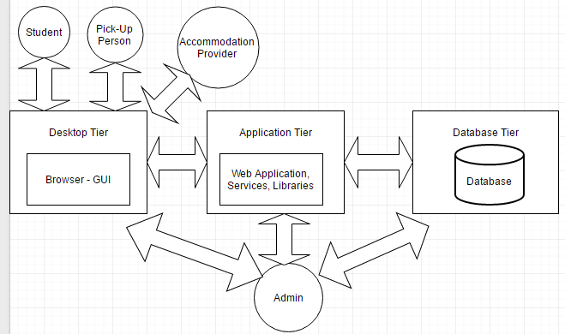

**7.2 Data Flow Diagram**

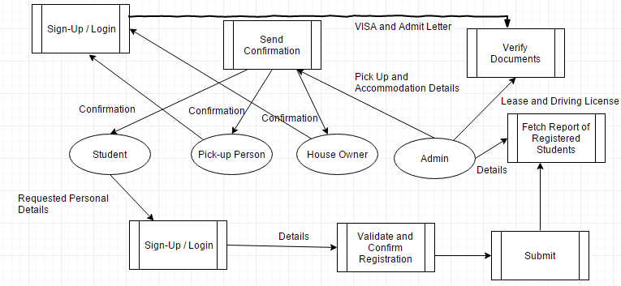

**7.3 Use Case Diagram**

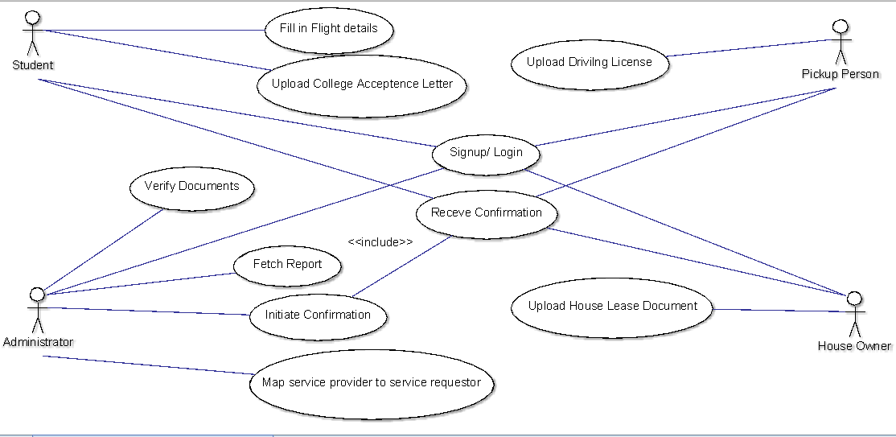

**7.4 Class Diagram**

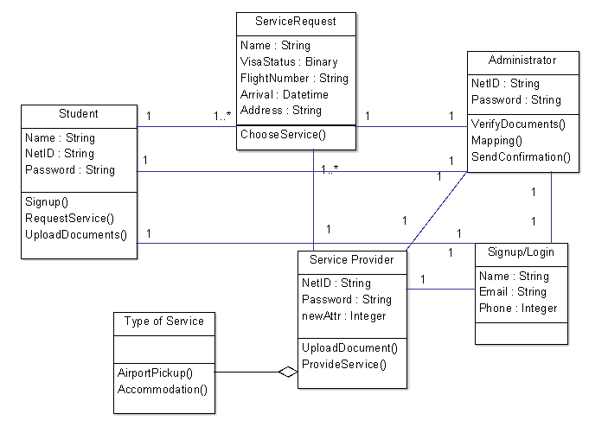

**7.5 Activity Diagram**

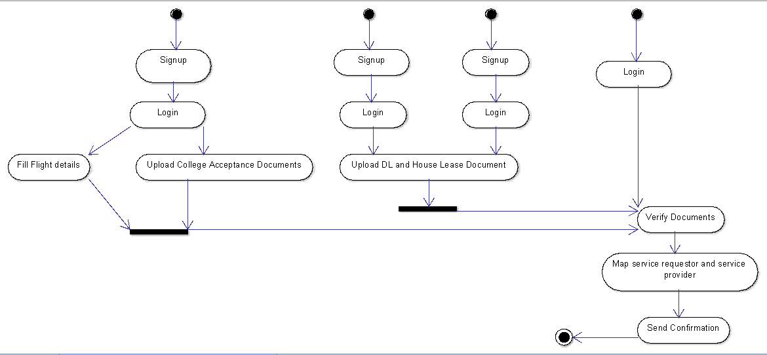

**7.6 Sequence Diagram**

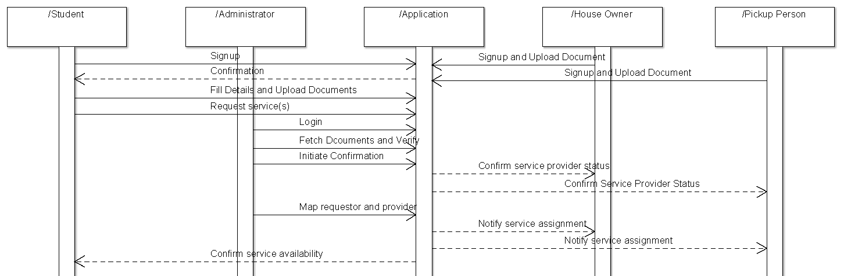

1. **System Documentation**

**8.1 Advantages**

* The system caters the need of both students and service providers on a single platform. Hence, this avoids lots of logistics and burdensome work for communication, thereby saving lot of time, effort and money.
* Since, there is a reliable team that verifies both student’s details and service provider’s details, individual security of both student as well as service provider is ensured.
* Easy to use and have quick response time.
* Highly available, since, we are preparing online system should be available 24 x 7.
* All Web pages generated by the system shall be fully downloadable.
* Proper design of interfaces and database connectivity ensures smooth data flow.
* Responses to queries shall take no longer than 10 seconds to load onto the screen after the user submits the query. Hence, catering high speed.
* The system shall display confirmation messages to users within 4 seconds after the user submits information to the system.
* Since, the system is designed using waterfall, reliability of the system is ensured in terms of technical aspects.
* Since, the system is designed dividing by components, reusability and reengineering of the code is easy to do.
* All network transactions that involve personal shall be encrypted.
* Members shall log in according to the restricted computer system access policy.
* The system shall permit users to view only their own previously placed information or records, not information placed by other members*.*
* If the connection between the user and the system is broken prior to any online process such as registration, registration either being confirmed or canceled, the System shall enable the user to recover an incomplete registration or transaction.
* Proper Disaster Management and recovery techniques should be implemented.

**8.2 Limitations**

* In case of high number of registrations, the system may encounter issues due to high traffic.
* There should be a dedicated team always up and running 24 x 7 to ensure that the servers are up all the time.
* The verification and validation process of the students and service providers is a big challenge in terms of time, authenticity and reliability.
* Since, it is developed in waterfall model, if any change in requirement arises that demand a component change in the middle, this could not accommodate.
* If this project continues for long time, it is susceptible for change which is not recommended.
* Costly affair if the development goes back a phase or two.
* Students or service providers will not get the login credentials immediately after they register, at least a two day working days of time is required to get the credentials.

**8.3 Session 9 Quiz 2: Product Metric**

Q. How will you develop software product metric for your team project?

Initially, we created a Software Product Metrics Program Proposal. In this proposal, we enlisted the metric(s) among a specific metric category for each phase of a software development cycle.

To select the project metrics, we considered several questions below:

1. What? - What metric(s) in this category during this phase can and should be collected? Then for each metric:
2. Where? - Where in the software development process is the metric collected? Is this point of metric collection clearly defined in the process?
3. Who? - Who is the responsible person for collecting, reporting, and analyzing the metric?
4. How? - How is the metric defined? What support (e.g., tool) is available in the development environment to collect, store, analyze, and report the metric?
5. Why? - Most importantly, why is the metric being collected, analyzed, and reported? How is the metric used to benefit this project and/or future software development projects?

**Software Product Metrics Program Proposal**:

|  |  |  |  |  |  |
| --- | --- | --- | --- | --- | --- |
| Development Phase /  Metric Category | Requirements | Design | Implementation | Testing | Field |
| Quality  - Defects  - Reliability | N/A | Reliability | Reliability | Defects | N/A |
| Complexity  - Size | N/A | Size | Size | N/A | Size |
| Productivity  - Schedule  - Effort | N/A | N/A | N/A | Efforts | Efforts |
| Stability  - Changes  - Rework | Changes | Changes | Rework | Rework | N/A |

The description of each Software Product Metric is given below:

1. **Defect**:
2. What - A defect is any flaw in the specification, design, or implementation of a product. The goal of software development is zero defects.
3. Where – In our project, defects are measured during testing phase.
4. Who – Among the four project members, two of us have worked on ensuring the defect data is recorded consistently across all testing activities.
5. How – We have performed Black Box Testing for our project. We tested the functional working of all the forms like sign up, login, student requests, admin request confirmation etc. which we have built.
6. Why - Defect metrics are the primary indicator of software quality. Because of its negative connotations, the metric must be used carefully so that it is not perceived as evaluating individual or group performance. We kept a goal to find and eliminate as many defects as possible and as close to their origin as possible.
7. **Reliability**:
8. What – Reliability in SDLC defines the extent to which software can be dependent on the different phases. Reliability should be the maximum possible.
9. Where – We have measured the reliability metric in Design and Implementation phase.
10. Who – All the team members have checked the reliability of underlying platforms and code which we have developed for this project.
11. How – In Design phase, we drew all the UML diagrams - Data Flow, Use Case, Class, Sequence and Activity in such a way that every functionality of our software is properly taken care. In Implementation phase, we divided each small functional part into separate modules. Once the modules are developed, we aggregated the modules and made sure that the entire code has no bugs present.
12. Why – Reliability metrics define the quality based on dependency constraints of different software activities. We have attempted to maintain the reliability as high as possible.
13. **Size**:
14. What – Size metric is essential to accommodate all the requirements of client. This metric represents the size constraints of the software.
15. Where - We have measured the Size metric in Design, Implementation and Field phase.
16. Who – The developers in our team overviewed the size metric being appropriately implemented.
17. How – We designed the information system based upon the requirements we received from the students and service providers (FOI, SIA communities etc.) who faced issues while availing airport pick up and temporary accommodation activities. In the implementation phase, we followed the SRS document to accommodate the requirements in the size metric of our system. If, in future, we need to increase the size of system, we will revise the size in Field (maintenance) phase.
18. Why - Size metric is a primary indicator of software complexity. Since our information system has a scope very limited to USF Tampa campus, the size metric is confined to minimal level.
19. **Efforts**:
20. What – Efforts is a metric which defines the productivity of a software. Effort estimation plays an important role on how the efforts are being invested in the product development lifecycle.
21. Where – We have considered this metric in Testing and Field phases.
22. Who – Two of the team members have worked on Efforts metric.
23. How – We calculated the efforts which we have invested in each of the phase in the testing phase. The calculations of how much efforts were invested against the output of the new software gives the productivity of the system.
24. Why – Efforts metric is a primary indicator of productivity of the software. Once the efforts are estimated, we concluded that our information system has very good output.
25. **Changes & Rework**:
26. What – Changes and Rework define the extent to which the software needs to be altered as per the requirements of either the customer or the resizing of application.
27. Where – We have considered Changes metric in Requirements and Design phases while Rework metric in Implementation and Testing phases.
28. Who - All the team members in our group have worked on Changes and Rework phases.
29. How - Initially we gathered few requirements and started with design phase, however we extended the requirements later and hence we implemented changes metric in design and Requirements phase. In the implementation and Testing phases, we restructured the Rework phase corresponding to changes metric in initial phases.
30. Why – Changes and Rework are the primary indicators of stability of the software. We kept a goal to carefully monitor the changes we need to implement in our project and rework accordingly.
31. **Future Recommendations and Scope**

This project is a great help for the students as well as the college student community who will be seeking and providing service respectively. Students, when they land into a new country, will be always in a need of a friendly hand who introduces them to the place and get them to get used to the environment. On the other hand, student service community always needs some entity to organize the student’s information to make the transition smooth.

The main idea of this project to develop an online common space to cater the needs of both students and service providers always deserves to get better than its rudimentary prototype. Currently, our system assumes not more than 1000 people can use the system at a time, hence the limitation. Incorporation of new technology, will enable this project to cater the need of many number of online users at a time.

An App:

If this idea is successful, then this project can become an evidence for huge success with widened horizons. Then, one can easily expand the idea for other universities and make it a generalized app, which facilitates as a huge help for incoming students as well as service providers.

Integrating social media:

Once, the idea comes into implementation and improves the scope, it can be integrated to the social media websites like Facebook, to get information or recommendations about the students who are really admitted to a particular university. This reduces the verification and validation efforts of an admin.

Feedback and rating system:

The students or the service providers who used the service will be sharing their feedback to the admin and provide some rating which would be visible for the other users. This will help the users to have some expectations on the quality of the service they expect. Furthermore, the rates can be classified based on the ratings that they get, compelling the service providers to provide the best quality service.

The Business Angle – Advertising:

This frequent usage of the app or website will increase the web count, thereby improving the popularity. This attracts various universities advertising agencies and to promote their colleges, thereby elevating the business angle for the website. Soon, it will grow as a big company which also can provide employment for the people who once availed the service and now graduated!!

The Analytics:

Finally, the trends and people who are availing a service for universities are observed. This would be like a common place for all the university to compare their intake. Also, if properly analyzed, the data can give perfect statistics about which nation’s people prefer which university, which airlines they use most etc., which gives lots of insights for business growth.

On an all, this system if implemented well, will be surely having a promising growth and scope to cater the students need in an efficient manner.

1. **Glossary and References**

<http://global.usf.edu/is/>